Khangai Herds 2- Saikhanaa and the Calves
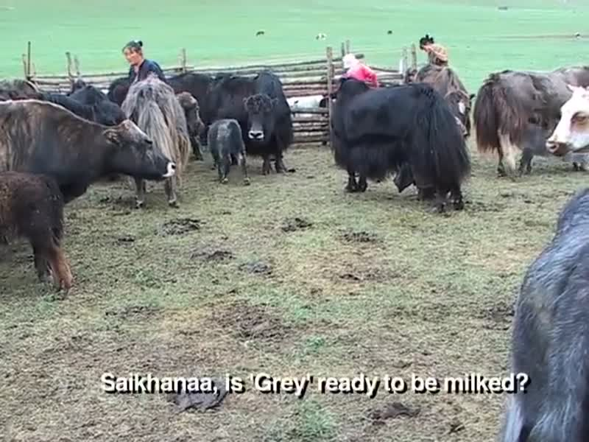

identifier
1cd0e36e-b17c-4524-9b05-43adc925394e

creator
Fijn, Natasha

type
Moving Image

coverage
Mongolia

description
This second segment of Khangai Herds features Saikhanaa the herder interacting with yak calves during milking time in the Khangai mountains of Mongolia. He indicates which calves belong to their respective mothers, showing a good knowledge of the genealogy of the yak herd.

publisher

source
<https://vimeo.com/13796152>

rights
<https://creativecommons.org/licenses/by-nc-nd/3.0/>

subject
Khangai Herds
Living with Herds
calves
co-domestic
ethnography
human-animal
milking
observational film
pastoralism
visual
yaks

date
2010-08-01

language
Mongolian

format
video/mp4

contributor

original filename
Khangai Herds 2- Saikhanaa and the Calves.mp4

remote embed url
https://player.vimeo.com/video/13796152

relation

extent
41.0MiB
481.233333

